**Human Factors Validation Test Results**

**Face Shield**

Dated April 24, 2020

Report by: Evan Sevieri

1. **Overview**

The Face Shield is a device that helps to protect the clinician from biological contaminants. This document is the test protocol to conduct Human Factors Usability Validation.

Face shields can substantially reduce the short-term exposure of health care workers to large infectious aerosol particles, but smaller particles can remain airborne longer and flow around the face shield more easily to be inhaled. Thus, face shields provide a useful adjunct to respiratory protection for workers caring for patients with respiratory infections. However, they cannot be used as a substitute for respiratory protection when it is needed.

This document outlines the results of clinical evaluation from anticipated users.

1. **Test Conditions**

This test protocol is to be conducted under test conditions that are identical to actual use conditions. The test follows the protocol indicated in the document *Face Shield Test Protocol – Human Factors*.

1. **Test Samples**

For this validation, a total of 15 samples will be used. These samples will be manufactured at Dr. Jennifer A. Lewis’ lab at the Wyss Institute and all components will meet all intended material, design and dimensional specifications for the product. The participants will also evaluate the out-of-the-box face shields currently used at the MGH (Critical Coverall).

1. **Questions**

Data that will be collected for this usability test include responses to questions related to comfort, coverage, ease of use, durability and other customer requirements. The questionnaire as seen by participants can be seen in Attachment 1. In addition to the questions listed below the participants were also asked their job title and gender. This set of questions was asked to each participant. The first set of questions participants were asked to rate features on a 1-5 scale from insufficient (1) to sufficient (3) to excellent (5):

|  |  |
| --- | --- |
| # | **Question** |
|  | Comfort |
|  | Fit |
|  | Visibility |
|  | Face Coverage/Protection |
|  | Fogging |
|  | Up/Down Range of motion |
|  | Left/Right Range of motion |
|  | Ability to stay in place during quick motions |
|  | Do and doff procedure |
|  | Compatibility with stethoscope |
|  | Compatibility with general PPE |
|  | Overall impression |

Three additional questions were posed to evaluate only the prototype shield, where the participant was asked to write a response:

|  |  |
| --- | --- |
| # | **Question** |
|  | Would you be able to wear the prototype face shield for your entire shift? If not, why? |
|  | What did you like about the prototype face shield? |
|  | Other comments/areas for improvement (if, any): |

1. **Participants**

The sample size of this test was given to be 15 participants (see Participants requirements in document *Face Shield Test Protocol – Human Factors*).

**Compensation:** No physicians were compensated as part of this study. However, it should be noted that 15 are under contract with MGH.

1. **Training**

No specific participant training was needed for this study. The study objectives and expectations will be explained to the participants prior to their evaluation.

1. **Environment**

Participants will use the Face Shield under actual conditions that incorporate typical environmental conditions that could impact use. The study will be conducted in a hospital environment. No additional use settings are anticipated based on the device’ use and its applicability.

1. **Summary of Results**

Participants in this study were residents and employees of the Trauma Surgery Department of Massachusetts General Hospital. 14 participants filled the surveys in total. A summary of average scores for the tested specifications is given in table below. Please refer to the full results of the prototype face shield in Attachment 2 and the Critical Coverall Face Shield in Attachment 3.

|  |  |
| --- | --- |
| Specification | Lewis Lab all plastic Face Shield  (average) |
| Comfort | 4.0 |
| Fit | 4.1 |
| Visibility | 3.9 |
| Face Coverage /Protection | 4.4 |
| Fogging | 4.3 |
| Up/Down Range of Motion | 3.6 |
| Left/Right Range of Motion | 3.6 |
| Ability to Stay in Place During Quick Motions | 3.7 |
| Don and Doff Procedure | 3.1 |
| Compatibility with stethoscope | 3.4 |
| Compatibility with general PPE | 4.0 |
| Overall Impression | 3.6 |

Attachment 1: Questionnaire

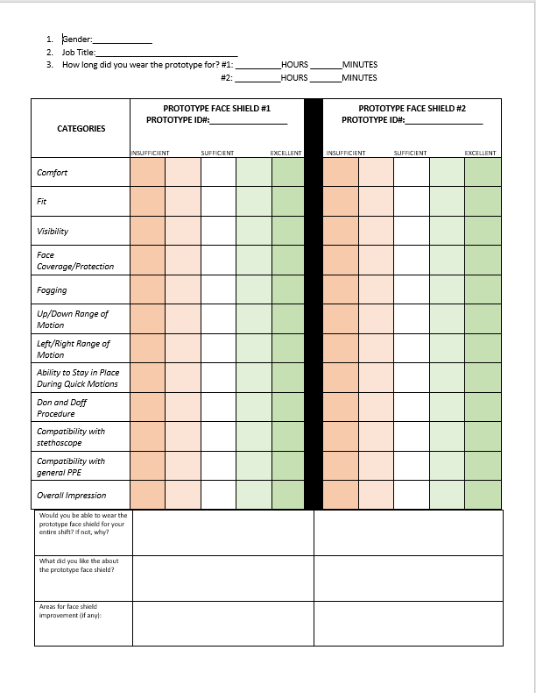

Attachment 2: Human Factors Test Raw Data, Lewis Lab Prototype: 4/10/2020

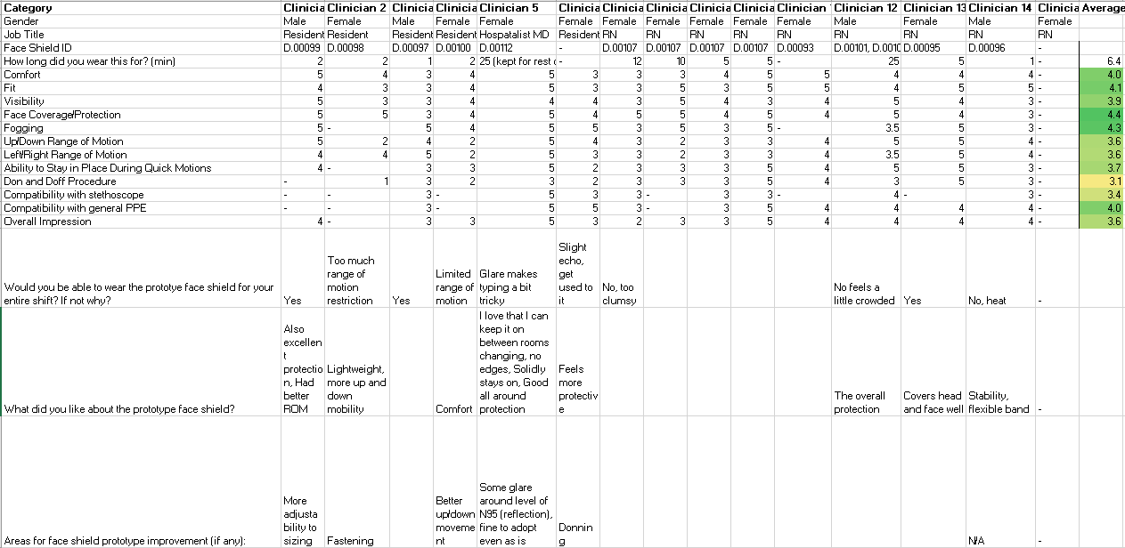

Attachment 3: Human Factors Test Raw Data, Critical Coverall Face Shield: 4/10/2020

